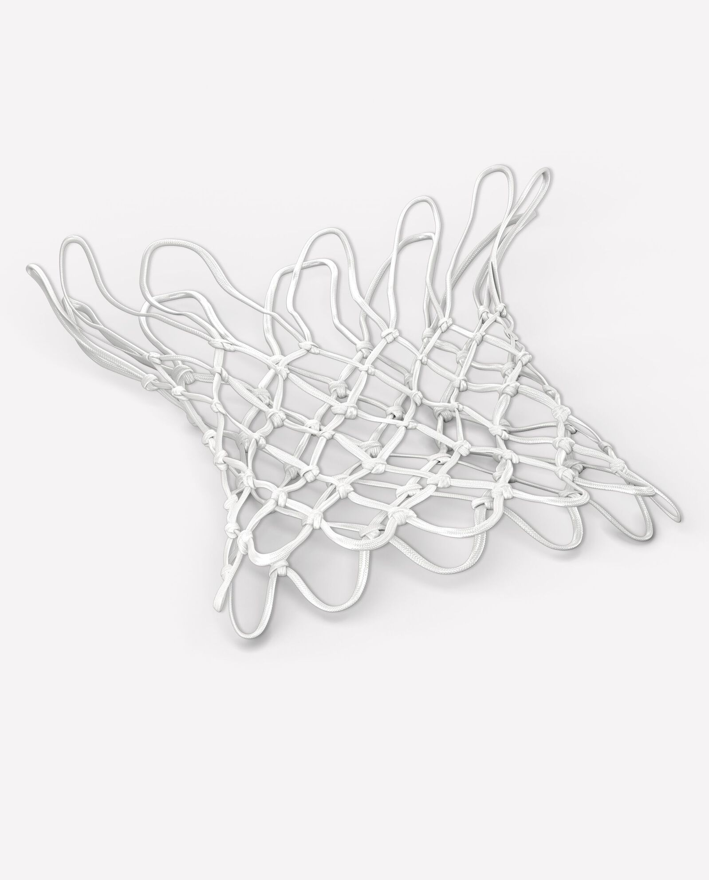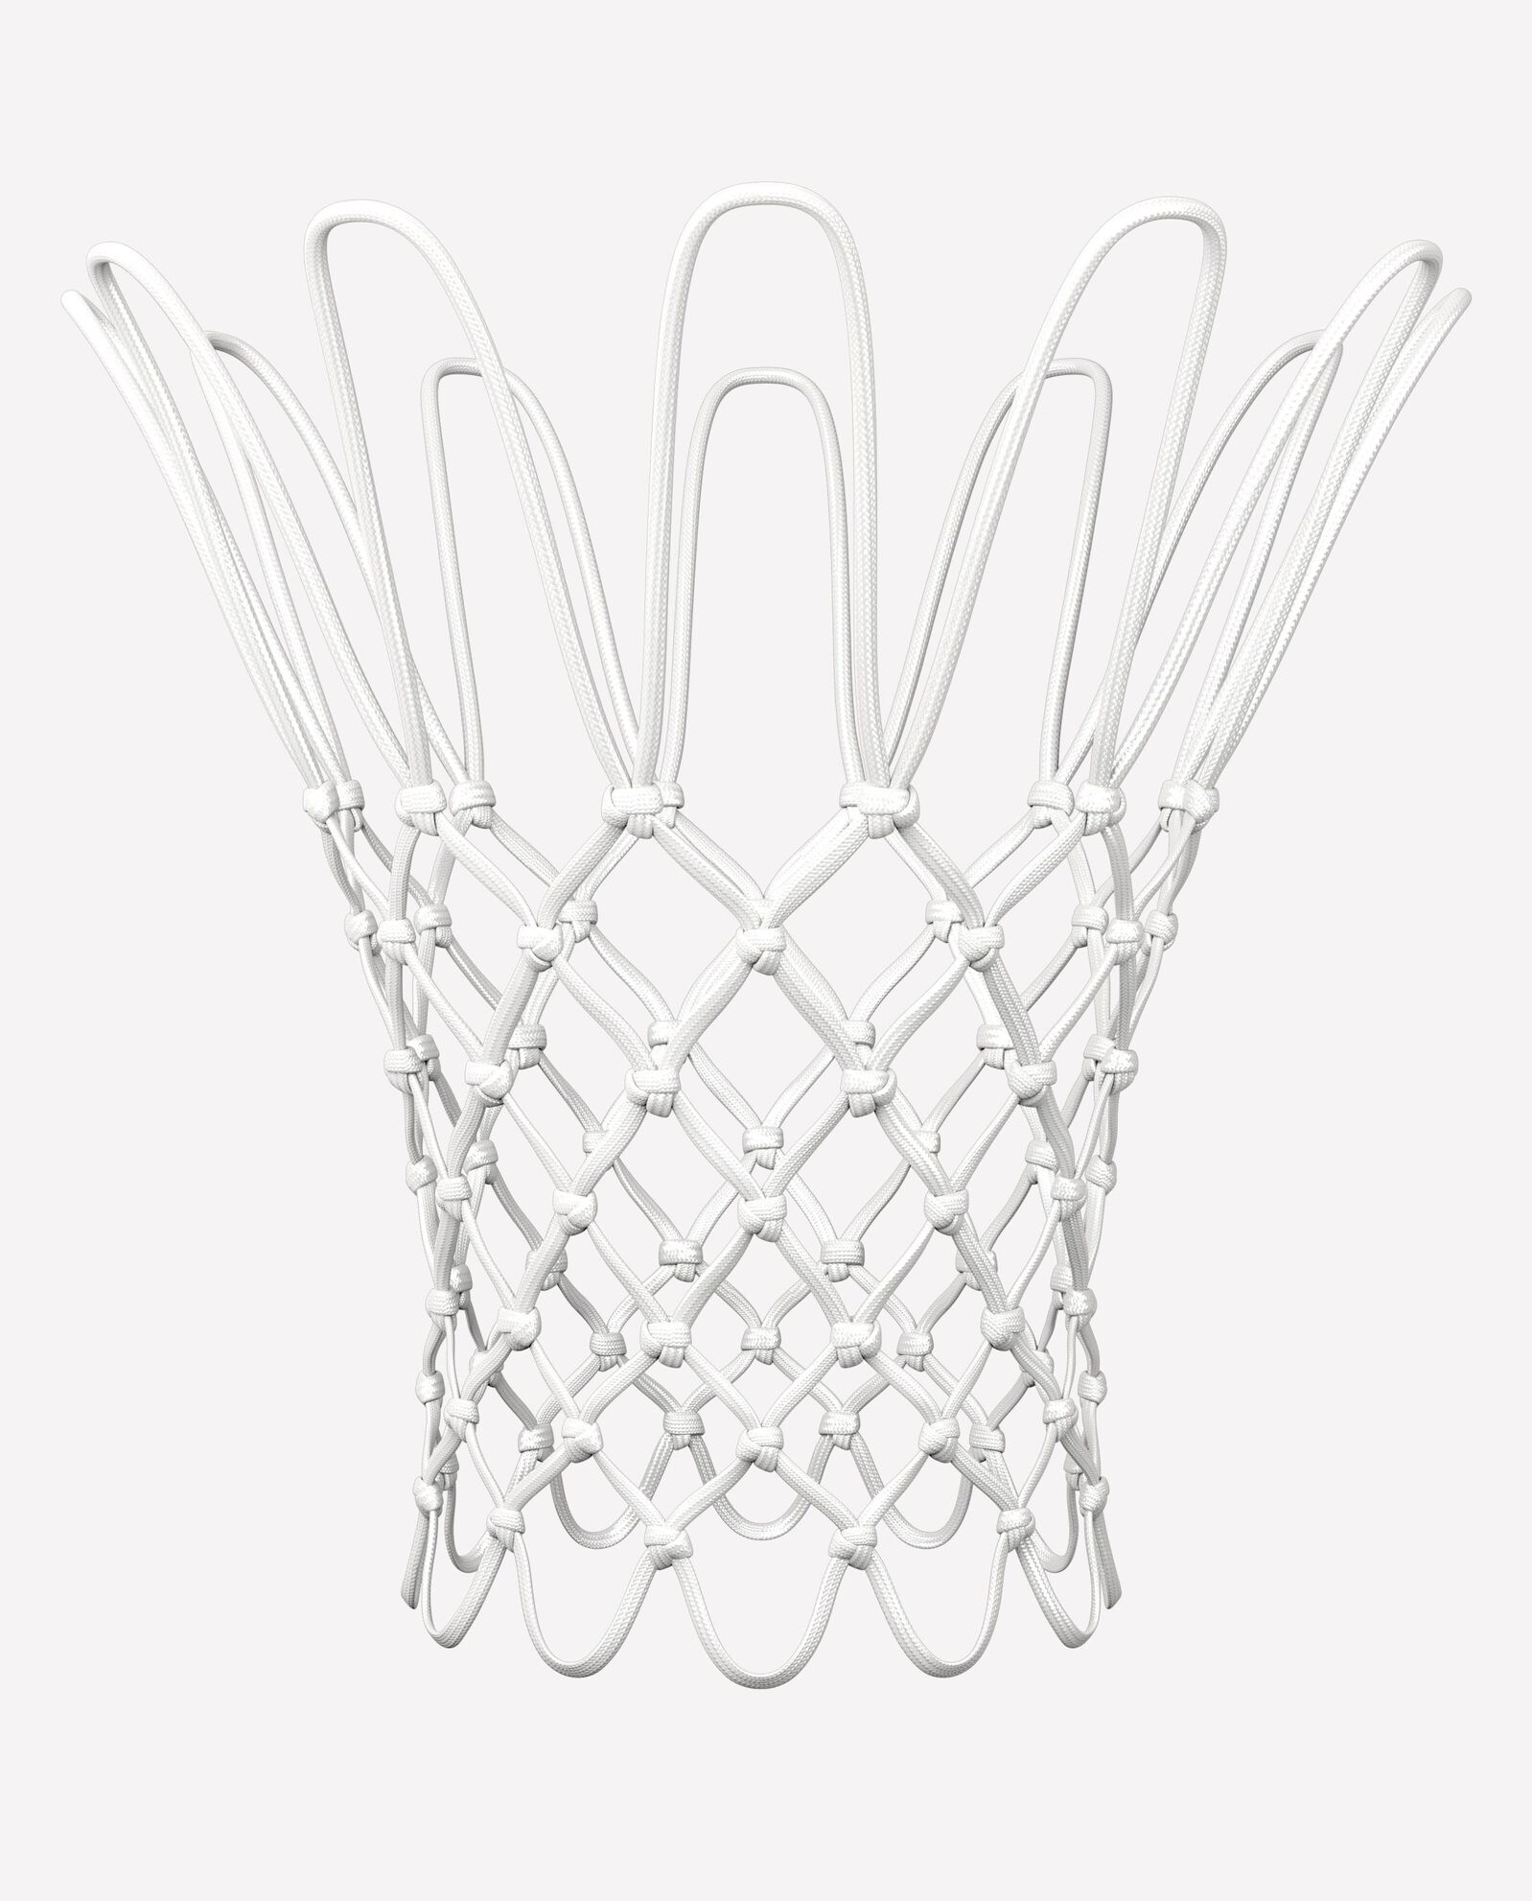

SPALDING OFFICIAL ON-COURT BASKETBALL NET

The swish of a net is one of the best sounds on the planet. Pour in points like the pros with the official on-court net. This net is hand-tied, with rigid loops at the top to prevent whipping. Built to handle the fiercest slams, it has a slightly stiff construction that softens up when you've earned the points.

**DETAILS:**

* Official on-court net
* Rigid loops at top to prevent whipping
* Polypropylene tips for durability
* Designed for indoor and outdoor play
* Backed by Spalding’s Warranty
* Item Number: 8509SP